SUMMARY
Does ChatGPT Actually Help Students Learn?
Findings from a Large-Scale Research Review

Original study: Wang, J. & Fan, W. (2025). The effect of ChatGPT on students’ learning performance, learning perception, and higher-order thinking: insights from a meta-analysis. Humanities and Social Sciences Communications, 12, 621.

Abstract (from the paper)
As a new type of artificial intelligence, ChatGPT is becoming widely used in learning. However, academic consensus regarding its efficacy remains elusive. This study aimed to assess the effectiveness of ChatGPT in improving students’ learning performance, learning perception, and higher-order thinking through a meta-analysis of 51 research studies published between November 2022 and February 2025. The results indicate that ChatGPT has a large positive impact on improving learning performance (g = 0.867) and a moderately positive impact on enhancing learning perception (g = 0.456) and fostering higher-order thinking (g = 0.457). The impact of ChatGPT on learning performance was moderated by type of course (Q_{B} = 64.249, P < 0.001), learning model (Q_{B} = 76.220, P < 0.001), and duration (Q_{B} = 55.998, P < 0.001); its effect on learning perception was moderated by duration (Q_{B} = 19.839, P < 0.001); and its influence on the development of higher-order thinking was moderated by type of course (Q_{B} = 7.811, P < 0.05) and the role played by ChatGPT (Q_{B} = 4.872, P < 0.05). This study suggests that appropriate learning scaffolds or educational frameworks should be provided when using ChatGPT to develop students’ higher-order thinking; the broad use of ChatGPT at various grade levels and in different types of courses should be encouraged; ChatGPT should be actively integrated into different learning modes, especially problem-based learning; continuous use of ChatGPT should be ensured with a recommended duration of 4–8 weeks; and ChatGPT should be flexibly integrated into teaching as an intelligent tutor, learning partner, and educational tool.

Summary: What This Study Did
Since ChatGPT launched in November 2022, educators have been experimenting with it—with mixed results. Wang and Fan tackled this confusion by conducting a meta-analysis, a statistical analysis method that pools data from many individual experiments to model aggregate effects. They gathered 51 experimental studies spanning thousands of students and combined their results into estimates of ChatGPT’s impact on three outcomes: learning performance (test scores), learning perception (motivation and engagement), and higher-order thinking (critical thinking, creativity, and problem-solving).
⚠ Misconception: “A meta-analysis is just a summary—it doesn’t tell us anything new.”
What the evidence shows: By pooling data across many settings, a meta-analysis can detect patterns no single study could reveal, estimate how large those patterns are, and test whether findings hold across different conditions. That said, it is only as strong as the studies it includes.

How Studies Were Selected
The researchers searched five major academic databases, initially identifying 6,621 articles. They then applied rigorous inclusion and exclusion criteria, narrowing the pool to 51 studies. The table below summarizes what qualified a study for inclusion.
Criterion | Included | Excluded
Study design | Experimental or quasi-experimental with at least one control group | Non-experimental designs (surveys, case studies, qualitative-only)
AI tool | ChatGPT specifically (GPT-3.5, GPT-4, GPT-4o) | Other AI tools (e.g., Copilot, Gemini, domain-specific AI)
Groups | Experimental group used ChatGPT; control group did not | Studies where both groups used ChatGPT, or neither did
Learning method | Same learning method for both groups (e.g. ChatGPT + lecture vs. lecture only) | Different methods across groups (e.g., gamification + ChatGPT vs. lecture only)
Control group tools | Normal/Traditional tools only (standard course materials, pen/paper, PowerPoint) | Emerging tech in control group (AR, VR, metaverse, specialized AI)
Learning process | Must involve an actual learning process | Using ChatGPT only as a utility (e.g., translation) without learning
Outcomes | Learning performance, perception, or higher-order thinking | Outcomes unrelated to learning (e.g., intention to adopt)
Data | Sufficient statistics to compute effect sizes (means, SDs, or t/F values) | Insufficient quantitative data
Language | Published in English | Non-English publications

These criteria help ensure the review compares like with like. By requiring the same teaching method for both groups and traditional-only tools in the control group, the researchers attempted to isolate ChatGPT’s specific contribution—though the quality of the conclusions still depends on the quality and diversity of the underlying studies.

The Key Findings
The combined evidence suggests that ChatGPT is associated with positive learning outcomes, though the size of the benefit varies by what is measured.
Outcome | Effect Size  (Hedge’s g) | What It Means
Learning Performance | 0.867 (large) | Students using ChatGPT tended to score higher on tests and assignments.
Learning Perception | 0.456 (medium) | Students reported feeling moderately more motivated and engaged.
Higher-Order Thinking | 0.457 (medium) | Moderate gains in critical thinking, creativity, and problem-solving.

A note on effect sizes: Researchers use effect sizes to express how big a difference an intervention makes. The measure used here, Hedges’ g, is expressed in standard deviation units—so an effect of 0.867 means the ChatGPT group scored, on average, about 0.87 standard deviations higher than the control group. In the social sciences, 0.2 is considered small, 0.5 medium, and 0.8+ large. These are rough benchmarks, not rigid thresholds, and a “large” effect describes the average trend across studies—not what happened to every individual student.
⚠ Misconception: “Higher test scores mean students are learning more deeply.”
What the evidence shows: Test scores capture what students can demonstrate on an assessment, but do not always reflect deep understanding or long-term retention. ChatGPT boosted scores substantially yet improved higher-order thinking only moderately—suggesting that some performance gains may come from better access to information rather than deeper conceptual mastery, though the evidence is not conclusive on this point.

What Conditions Appeared to Matter?
Beyond overall effects, the researchers examined whether certain conditions were associated with stronger or weaker outcomes. These moderator analyses are exploratory—the number of studies in some categories was small, so these findings should be treated as tentative rather than definitive.
Duration. Duration was a significant moderator for both performance and perception. Very short exposures (under one week) were associated with the weakest performance gains, possibly because students need time to learn effective prompting. The strongest performance effects appeared in the four-to-eight-week range, with somewhat smaller effects at longer durations—though few studies examined extended time periods, so this pattern is preliminary. The data hint at diminishing returns with very prolonged use, possibly from over-reliance, but this should not be taken as a firm prescription: what seems clearest is that very brief exposures are insufficient. For perception, longer use was associated with more positive attitudes.
Course type. ChatGPT appeared effective across STEM, language and writing, and skills-training courses. For higher-order thinking, STEM courses showed the largest estimated benefit—perhaps because those courses involve complex projects that exercise critical and creative thinking—but this finding rests on a small number of studies.
Learning model. The largest performance effects were observed in problem-based learning contexts, where students work through realistic, open-ended problems. ChatGPT’s capacity to explain concepts and generate potential solutions may be especially useful here, though more research is needed to confirm this pattern. Project-based learning showed the smallest estimated benefit.
ChatGPT’s role. For higher-order thinking, the strongest effects were associated with using ChatGPT as an “intelligent tutor”—providing personalized guidance, feedback, and assessment—rather than as a simple reference tool. (“Intelligent tutor” meant the way ChatGPT was used and/or ChatGPT with a default prompt to act as a tutor, or more sophisticated tutors built on top of ChatGPT.) However, several role categories had too few studies for reliable analysis.
Important Caveats
The evidence base is still small and uneven: 44 studies examined performance, but only 19 addressed perception and 9 addressed higher-order thinking. Nearly all involved college students, so generalization to younger learners is uncertain. Only controlled experiments were included, meaning qualitative insights are absent. ChatGPT itself has evolved rapidly since late 2022, so some findings may not reflect current versions. And the underlying studies varied in quality, sample size, and context—variation that meta-analytic averages can obscure.
⚠ Misconception: “This proves ChatGPT works for all students in all settings.”
What the evidence shows: Meta-analyses reveal overall trends but can mask important variation. Most studies here were conducted under controlled conditions with college students—a narrow slice of the full educational landscape.

Practical Considerations
For educators and administrators weighing how to integrate ChatGPT, this research offers several recommendations.
Allow adequate time. Very brief exposures appear insufficient. Students likely need time to develop effective prompting skills before ChatGPT can meaningfully support their learning.
Provide scaffolding. ChatGPT alone does not appear to automatically develop higher-order thinking. Pairing it with instructional frameworks and teaching students to ask probing questions may be important.
Be intentional about context. The evidence suggests ChatGPT may be especially useful in problem-based learning and when positioned as a tutor with interactive use.
Monitor for over-reliance. Building in formative assessments and independent work may help ensure ChatGPT remains a learning tool rather than a substitute for student effort.
Remember the human element. ChatGPT’s impact on motivation was more modest than on scores. Teachers continue to play a central role in relationship-building and intellectual curiosity.

The Bottom Line: Across 51 studies, ChatGPT is associated with meaningful improvements in academic performance and moderate benefits for motivation and thinking skills. But the way it is integrated matters: how it is used, in what context, and with what instructional support all shape its effects.
(Added by Dr. Greg) Weakness of this meta-analysis: The meta-analysis did not consider potential harms beyond the immediate learning outcome variables measured. Studies were generally about one course/environment and AI use and effects might vary over time or with longer use.
—
OPTIONAL: AI USE PROCESS
COMMENTARY:
I’m sharing my process here to help show some of the kinds of quality issues when making summaries for meta-analyses (and perhaps in summarizing academic papers more generally). Also see the iterative prompting I did to correct that the initial output was initially “over-confident” (at the same time the actual paper was itself perhaps a little over-confident).
I also used a constraint on the output length instead of specifying all the parts I wanted to include from the beginning. So when prompting with a less detailed prompt, I knew I would need to read the output to see if any parts were missing or “overdone” relative to the space. But in this case the additions I needed to prompt to add were fairly minor.
Then I edited it manually to fix some claims that were not quite correct or were “off” - it is much easier to simply delete such parts of the output instead of trying to “correct” them. This is an important skill for using AI outputs, some of the output will be inaccurate or not quite right, and it’s better to simply just delete the offending parts. For example, in response to my prompting to be less certain, the output went a little too far - that kind of fine last adjustment, at least in this case, was easier to make by hand e.g. removing “a starting point, not a final verdict” which isn’t appropriate for a 50 study meta-analysis which actually gives quite a lot of information.
Edits Dr. Greg Made:
I made edits to the output shown below. (I also the next day skimmed the summary again and made some edits with track changes on to improve clarity)
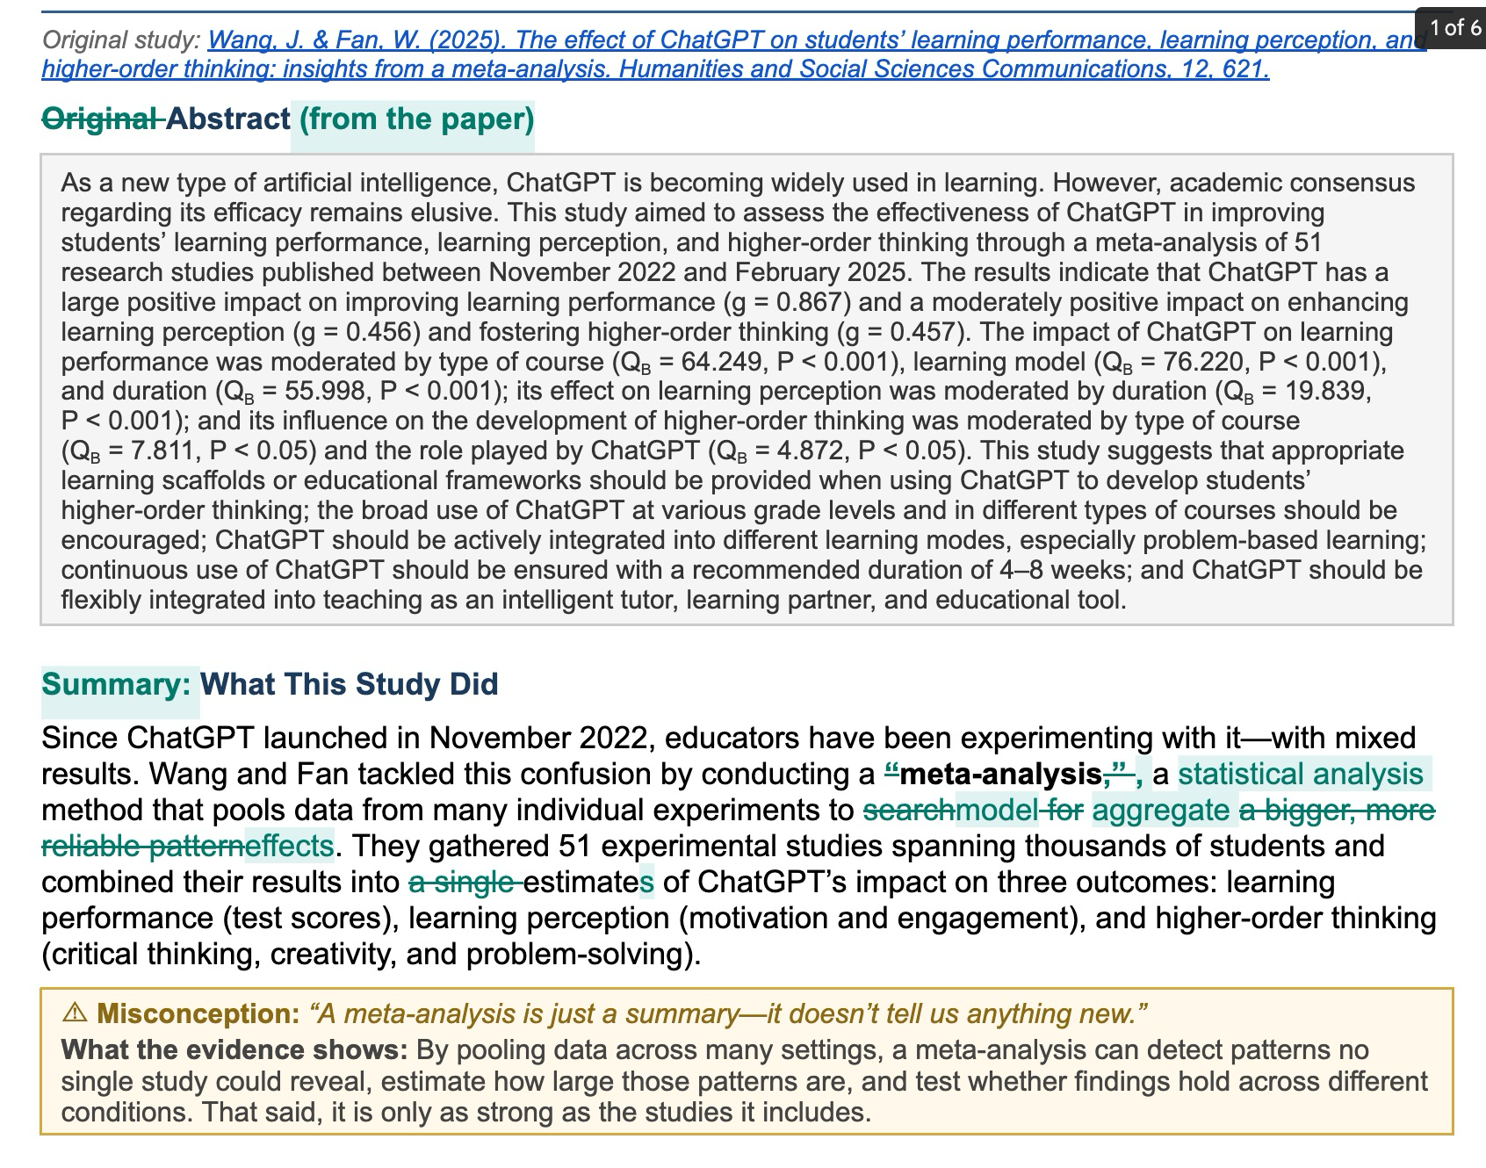
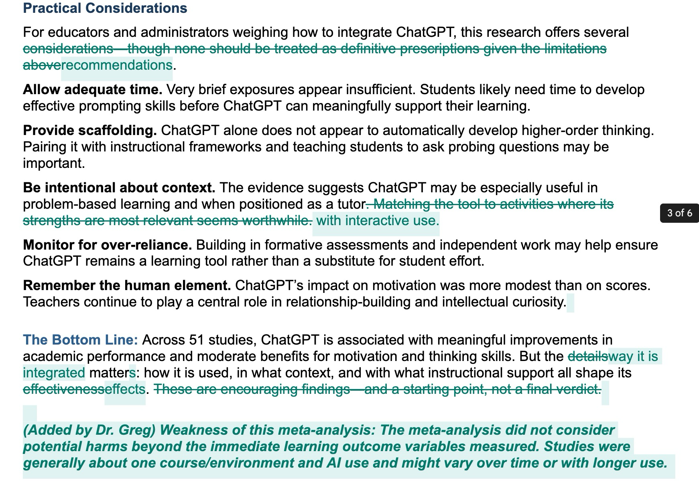
Prompts used to help generate this summary:
Prompt Design Rationale: I didn’t use a typical role prompt (Acting as a ….), as I wanted an accessible summary. Generally the AI output is tuned to a kind of “average response” which happens to align with a generally accessible summary. It happened to work reasonably well so I didn’t refine it. (Also note that some typos in prompts can be ignored instead of needing to correct them e.g. iwth)

Me: Create a 2 to 4 page summary of this paper that is accessilbe to people that are not familiar iwth what a meta-analysis is:

Acknowledged task completion without substantive deliberation
Acknowledged task completion without substantive deliberation
Here's your summary. It runs about 3 pages and is written for a general audience — no assumed familiarity with meta-analysis, effect sizes, or research methodology. I included a brief plain-language explanation of what a meta-analysis is and what effect sizes mean, a summary table of the three main findings, the key conditions that shaped ChatGPT's effectiveness, caveats, and practical takeaways.
Chatgpt learning summary
Document · DOCX
Me: Integrating addressing the most common misconceptions learners might have

Synthesized strategies for addressing learner misconceptions
Synthesized strategies for addressing learner misconceptions
Here's the revised summary. I integrated six misconception callout boxes (visually distinct with amber-tinted backgrounds) at the points in the document where readers are most likely to form the wrong conclusion:
"A meta-analysis is just a summary" — after explaining what the study did
"Large effect size means every student benefited" — after presenting the results table
"Higher test scores = deeper learning" — after noting the gap between performance and thinking gains
"More ChatGPT is always better" — after the duration findings
"ChatGPT automatically develops critical thinking" — after the role/scaffolding findings
"This proves ChatGPT works for all students" — after the caveats section
Each callout states the misconception in the reader's voice, then corrects it with what the evidence actually shows.
Chatgpt learning summary
Document · DOCX
Me: Turn this into a 3 page version and include the original study's abstract

Condensed document to three pages with abstract and misconception boxes
Condensed document to three pages with abstract and misconception boxes
Here's the revised version — confirmed at exactly 3 pages. Key changes from the previous draft:
Added the original abstract in a gray box near the top, with proper subscript formatting for the statistical notation
Tightened all prose throughout — condensed the "What This Study Did" section, merged the conditions sub-sections into a more compact format, and trimmed the caveats to a single paragraph
Retained all six misconception callouts, just with slightly more concise correction text
Slightly reduced font sizes and margins to fit the additional abstract content within the 3-page target
Chatgpt learning summary
Document · DOCX
Me: include the study inclusion/exclusion criteria

Identified inclusion criteria and strategized space-efficient integration
Identified inclusion criteria and strategized space-efficient integration
Claude's response was interrupted
Me: Remove the over-emphasis on the takeaways on four to eight weeks, and reduce certainty in the what conditions matter most and generally in interpretation of the findings

Recalibrated emphasis and softened interpretive certainty throughout
Recalibrated emphasis and softened interpretive certainty throughout
Running a bit long at 4 pages. Let me tighten the spacing and trim some prose.
Recalibrated emphasis and tempered interpretive certainty throughout
Recalibrated emphasis and tempered interpretive certainty throughout
Close — just the last two takeaways and the bottom line overflow. Let me trim those.
Verified document formatting across multiple pages
Verified document formatting across multiple pages
3 pages confirmed. Let me verify the layout looks clean.
Reviewed document layout and prepared final presentation
Reviewed document layout and prepared final presentation
All three pages look clean. Let me present the final version.
Recalibrated emphasis and tempered interpretive certainty throughout
Recalibrated emphasis and tempered interpretive certainty throughout
Here's the revised 3-page summary. Key changes from the previous version:
De-emphasized the 4–8 week finding. It's now mentioned once in the duration paragraph as one data point among others, with explicit caveats about the small number of studies at longer time scales. The dedicated "more is always better" misconception box was removed and its core point folded into the prose. The practical takeaways section now says "allow adequate time" without specifying a number.
Reduced certainty throughout. Language across the conditions section and interpretations now uses hedged phrasing: "associated with," "appeared to," "suggests," "the data hint at," "this pattern is preliminary," "rests on a small number of studies," etc. The section heading itself was changed from "What Conditions Matter Most?" to "What Conditions Appeared to Matter?" and the intro explicitly labels the moderator analyses as exploratory. The practical takeaways section is now titled "Practical Considerations" with a disclaimer that none should be treated as definitive prescriptions.
Added the inclusion/exclusion criteria table with all nine criteria from the original study.
Chatgpt learning summary
Document · DOCX
Me: Add a couple sentences about the discussion in the paper on novelty effects being responsible

Searched paper for novelty effects discussion, found none explicitly mentioned
Searched paper for novelty effects discussion, found none explicitly mentioned
I went back through the paper text you uploaded, and I'm not finding an explicit discussion of novelty effects in it. The duration discussion frames the short-term weakness as students lacking effective prompting skills, and the long-term decline as over-reliance — but doesn't use the novelty effect framing specifically.
Is there a particular passage you have in mind, or would you like me to add a sentence noting that novelty effects are a plausible alternative explanation for the pattern (as a reader-facing interpretive note rather than something the authors themselves raised)?

Me: Add a one sentence explanation of the units of Hedge's g, the effect size measure, i.e. "in standard deviation units"

Reconsidered document structure and verified content completeness
Reconsidered document structure and verified content completeness
Still 3 pages.
Presented file
Presented file
Added a sentence to the effect size note: "The measure used here, Hedges' g, is expressed in standard deviation units—so an effect of 0.867 means the ChatGPT group scored, on average, about 0.87 standard deviations higher than the control group."
Chatgpt learning summary
Document · DOCX

